234页第二题

#include<iostream>

using namespace std;

class student

{

public:

char name[100];

unsigned int id;

double score;

void input(student&);

void output(student&);

};

void student::input(student&stu)

{

cout << "name？";

cin >> stu.name;

cout << "id？";

cin >> stu.id;

cout << "score?";

cin >> stu.score;

}

void student:: output(student&stu)

{

cout << "name:" << stu.name << "\tid:" << stu.id << "\tscore:" << stu.score << endl;

}

int main()

{

student s ;

s.input(s);

s.output(s);

system("pause");

return 0;

}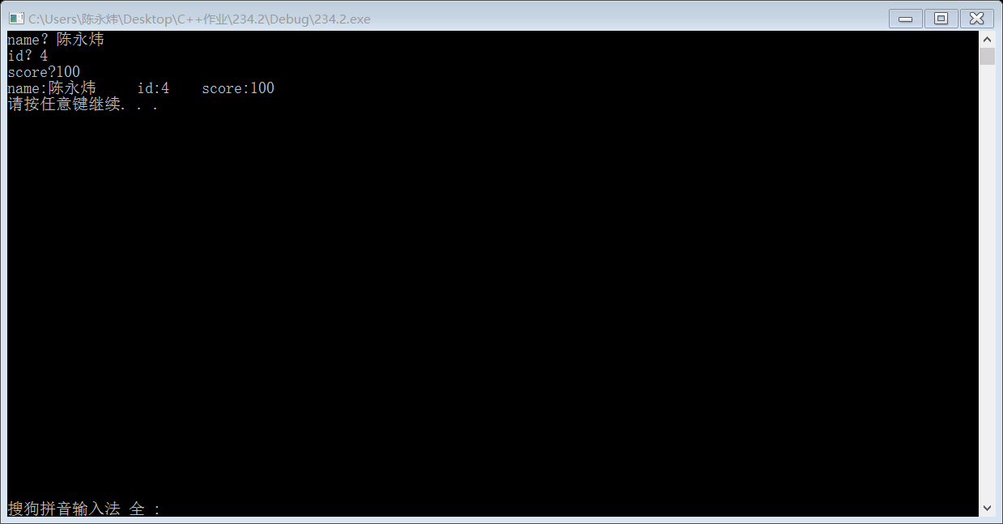

242页第1题

#include<iostream>

#include<cstring>

using namespace std;

class Book

{

public: char bookname[20];

double price;

int number = 10;

void display();

void borrow();

void restore();

};

void Book::display()

{

cout << "bookname:" << bookname<<endl << "price:" << price<<endl<<"Now total number is:"<<number<<endl;

}

void Book::borrow()

{

number--;

cout << "Now total number is:" << number<<endl;

}

void Book::restore()

{

number++;

cout << "Now total number is:" << number<<endl;

}

int main()

{

Book b;

int i,choice;

strcpy_s(b.bookname, "Huang Jin Shi Dai");

b.price = 36.25;

b.display();

do{ cout << "Please chhoose:\n" << "Key in 1 is borrow\n" << "Key in 2 is resore\n" << "Key in 0 is over.\n";

cin >> choice;

switch (choice)

{

case 1: {b.borrow(); break; }

case 2:{b.restore(); break; }

case 0:break;

}

} while (choice);

system("pause");

return 0;

}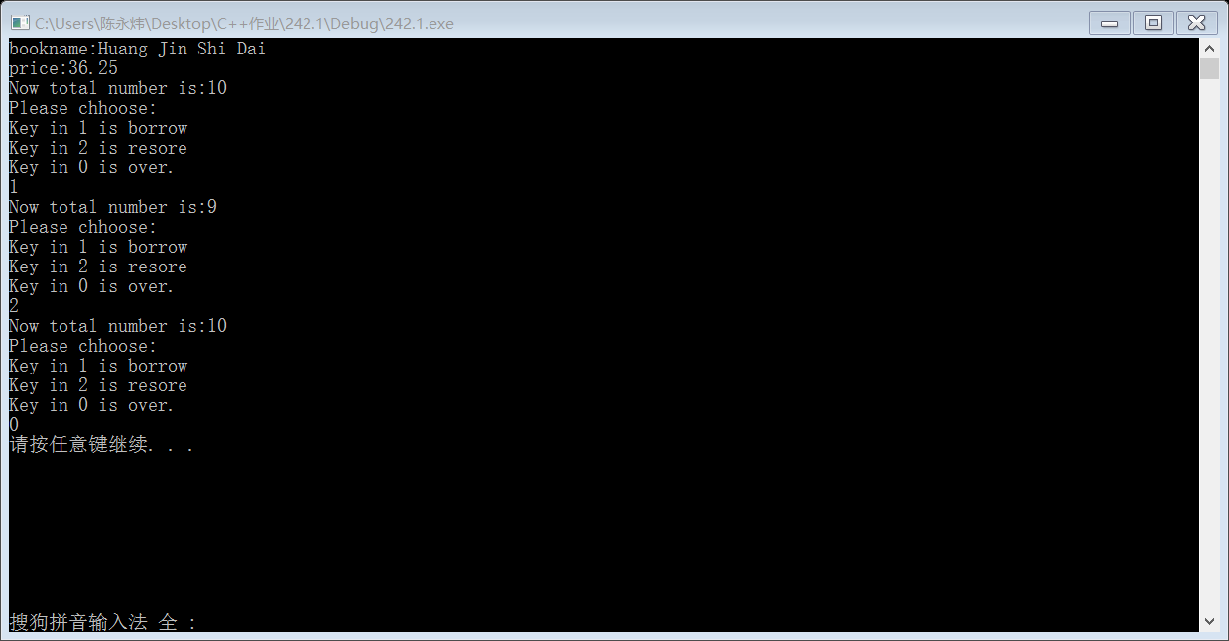

242页第3题

#include<iostream>

using namespace std;

class Student

{

private:double score;

static double total;

static int count;

public:void scoretotal(double);

static double sum();

static double average();

};

double Student::total = 0;

int Student::count = 0;

void Student::scoretotal(double s)

{

score = s;

total += s;

count++;

}

double Student::sum()

{

return total;

}

double Student::average()

{

double x;

x = total / count;

return x;

}

int main()

{

int number;

cout << "请输入本班学生人数：";

cin >> number;

Student stu[1000];

double sco;

for (int i = 1; i <= number; i++)

{

cout << "请输入第" << i << "位学生分数:";

cin >> sco;

stu[i - 1].scoretotal(sco);

}

cout << "全班总分：" << Student::sum() << endl;

cout << "班级平均分：" << Student::average() << endl;

system("pause");

return 0;

}